City of Batavia
Media Release

FOR IMMEDIATE RELEASE:

Vacancies on Zoning Board of Appeals

Why in the world is there a business sitting next to two private homes in the City? Why do the City’s code enforcement officers allow one property owner to build onto a structure and yet deny another? If these are the kind of questions you find yourself asking as you drive through the City of Batavia, you may be the perfect person to fill an opening on the City’s Zoning Board of Appeals (ZBA). The ZBA needs City residents who are curious about and interested in zoning regulations as it relates to buildings and structures.
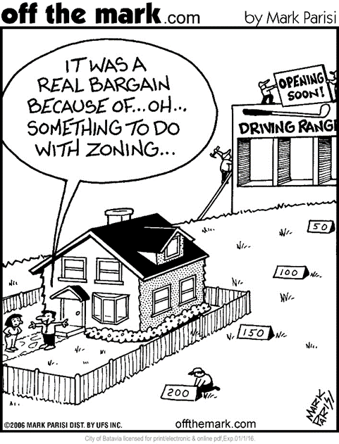
The ZBA is responsible for hearing and determining appeals of refusals of building permits or certificates of occupancy when the denial is based on zoning requirements. The ZBA has the authority to change the application of the zoning regulations relating to buildings and structures and helps to address practical difficulties and unnecessary hardships to ensure proper zoning in the City. The board meets once a month and requires a time commitment of approximately 12 hours per year of its volunteers.

Residents interested in applying can obtain an application from the City Clerk’s Office or can visit our website at www.batavianewyork.com and download a Committee/Board Volunteer Application under Documents.

Applications are due to the City Clerk’s Office by November 30, 2015.

If you have any questions or need additional information, please contact the City Clerk’s office at (585) 345-6305 or:

Office of the City Manager
One Batavia City Centre
Batavia, New York 14020
Phone: (585) 345-6330
Fax: (585) 343-8182
E-mail: jmolino@batavianewyork.com

Jason Molino
City Manager

Dated: November 10, 2015

